LAB Instruction
Lab 02

What You Will Learn
- How to create internal hyperlinks
- How to add images and tables to a Web page
- How to use semantic markups in HTML
HTML and Semantic HTML
Copyright Randy Connolly @ 2011

Modified by Yasaman Amannejad, 2019
and again by PJ Perri, 2023
and again by Jim Davis 2024

Linking
Download the GamePortalSite from the Lab02.folder. It is a zip archive provided for this lab. Unzip it on your computer. Use the file index.html found in that directory to complete the following steps. At the same time, prepare a Word docx that includes your answers to the questions. Name it Questions.docx and save it in your Lab 02 folder. When you look up an answer, cite it with a footnote to the source you used.
- In the list, add a new item and link:
<li><a href="gameSystems.html">Our Favourite Game Systems</a></li>
Save changes and test in browser. This will create a link to another file on the website. You will create this file later in this lab.
- Add the following near the top of the page and test:
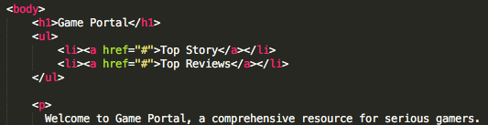
The # sign simply indicates a link to the same page. This is a common technique for temporarily creating links whose destinations are not yet known or created.
- Now, add id attributes to Top Story and Top Review such that these items link to the Top Story and Top Reviews headings. Update the anchor links as needed. When you click on Top Story it should jump to the Top Story paragraph. Test this by clicking on the bulleted list of links. Example if you add id=”topstory” inside the <h2> tag and then change the Top Story link to href=”#topstory” then clicking on that link will move the page down to the Top Story

Adding Images
- Add the following image tag to your code:
Add a title attribute to this image: “StarCraft 2”. Save and test the code. Be sure to hover on the image.
BTW. This image is a modified version of an image from https://www.pxfuel.com/en/query?q=brutal+doom.
Use the cite element with this information and add a citation below the image.
Hint: use <br > to force a line break.
Right click on the image and choose Inspect. What are the image’s dimensions? Modify the image tag by adding width and height, to make the image about half as tall. Be sure to keep the image’s proportions!
Based on your experiences with this image, OR after doing some research,
What is the purpose of using title attribute in an image tag?
What is the purpose of using alt attribute in an image tag?
- Change the src attribute to the following (i.e., add a slash before the folder name) and test. You will no longer see the central park image.
What does the browser show?
- Remove the slash added in step 3.
Why does a root reference not work for this src attribute? Why are relative references better for web page images?
- Just after this line:
…StarCraft II the ultimate competitive real-time strategy game. </p>
and before the <h2>Top Reviews</h2>,
add the following code and test it:
<p>Rating:
<img src="images/full-star.gif" title="full star" />
<img src="images/full-star.gif" title="full star" />
<img src="images/full-star.gif" title="full star" />
<img src="images/full-star.gif" title="full star" />
<img src="images/empty-star.gif" title="empty star" />
<a href="#">Read More</a>
</p>
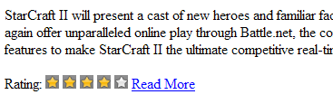
<h2>Top Reviews</h2>
Notice the space between each star image.

- Now, remove the returns between each <img> tag, as shown below, and then test.
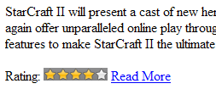
<img src="images/full-star.gif" title="full star" /><img src="images/full-star.gif" title="full star" /><img src="images/full-star.gif" title="full star" /><img src="images/full-star.gif" title="full star" /><img src="images/empty-star.gif" title="empty star" />

What changes do you see? Why removing the carriage returns changes the output?

Adding HTML5 Semantic Elements
HTML5 introduced a number of new semantic elements that can make your markup more understandable and thus easier to maintain. The next set of exercises introduces several of these elements.
- Just where the body element is opened, add the following and test:
<header>
<h1>Game Portal</h1>
<ul>
<li><a href= “#topStory”>Top Story</a></li>
<li><a href= “#topReviews”>Top Reviews</a></li>
</ul>
</header>
- Add the following code to the end of the file, before the </body>:
<footer>
<p>Copyright &copy; 2015 Game Portal</p>
</footer>
</body>
</html>
Note the changes from these two elements.
What is the purpose of each of these two semantic elements to a page?
What symbol does the character entity &copy; create? (Make sure to check the full list of character entities in your course slides!)
- Identify the logical parts of your document and add <nav>, <article> and <section> elements to your Webpage. Note that there is no special browser formatting for most of HTML5 semantic elements. They are used purely to make our markup clearer. Later we will learn how to use Cascading Style Sheets to adjust the appearance.
Add figure and caption elements for the starcraft.jpg image that you created previously. Figure element comes with formatting style, you should be able to see the change when you added the <figure> element.
What change do you see when you add these two elements around your image?
Note that the <figure> element should be used only for images that are essential but whose position on the page could change. The star icons used for the rating are not essential; they should not be contained within a <figure>.

More on next page

Creating Table in HTML
  - At the end of Starcraft 2 section, create a table that looks like the following table.
Table 1 – Review Scores
Review scores
Publication | Score
IGN | 9/10
Softpedia | 9/10
AusGamers | 9/10
4Players | 8/10
PC Games | 10/10
Average | 9/10
Include the code for this table in your lab report.

Validate your HTML file
- Validate your file and if there is any error or warning fix them.

Creating a New Web Page
  - Create a new page named gameSystems.html file that uses appropriate HTML semantic elements:
- header for the page: include h1 heading: Game Portal on Gaming Systems
- nav: links to the two articles
- Section: with a header: h2 heading: Our Favourites
- Articles: for any two game systems you like include:
  - A header with a h3 heading
  - A Paragraph of content
    - You can use this site to generate filler paragraphs.
  - A footer with a link to that system’s official web site opened in a new tab
- Figure and figcaption:
  - An image of a game system – you will need to search for one:
    - Must have a creative commons license
    - proportionally sized to be 100 pixels tall
    - include a caption describing it and <cite> as needed – ideally URL’s are links.
- a footer for the page: use <small> and include a copyright notice symbol, your name, the page’s creation date and time
More on next page

<header>
<nav>
<section>

<article>
<article>

<figure>
<figcaption>

<footer>
The page will look something like the image on the next page.
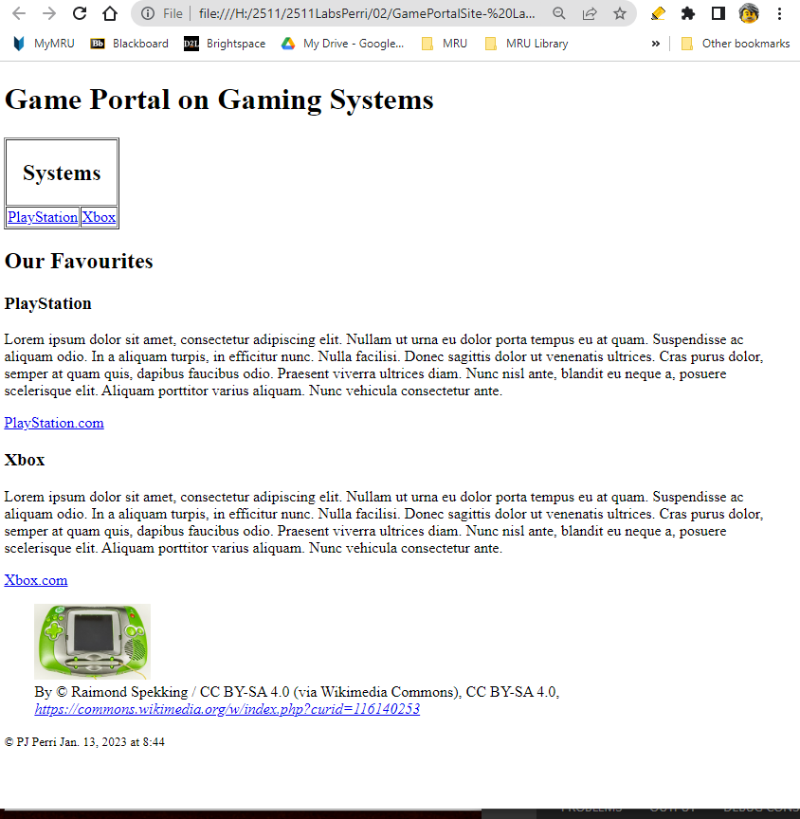
  - Save this new page so that it is in the same directory as the earlier index.html file. Ensure that the link on the index.html file goes to this file.
  - Validate your file when you have finished.

Submission
Create a folder, or rename the one you have to Lab02_lastname_firstname Make sure it contains the images folder, both html files and your Questions.docx file. If necessary, zip the folder and put a copy into the Submit folder for the class. (AcadShare1/Labs/CompSci/Submit/2511/002)

